EXP NO : 8 Implement Boosting Technique (AdaBoost) and Analyze Performance

AIM : To implement the AdaBoost Classification algorithm using Python to predict students' results based on their study hours, attendance, and assignments, evaluate the model using accuracy, confusion matrix, and classification report, and visualize the importance of each feature using a bar graph.

ALGORITHM :
- Start the program.
- Import Pandas, Matplotlib, and the required functions from Scikit-learn.
- Load the dataset from the file data.csv.
- Select Hours_Studied, Attendance, and Assignments as input features.
- Select Result as the target variable.
- Split the dataset into training and testing sets in an 80:20 ratio using train_test_split().
- Create an AdaBoost classification model using AdaBoostClassifier(n_estimators=50, random_state=42).
- Train the model using the training data with model.fit().
- Predict the results for the testing data using model.predict().
- Calculate and display the accuracy using accuracy_score().
- Display the confusion matrix using confusion_matrix().
- Display the classification report using classification_report(), which includes precision, recall, and F1-score.
- Extract the feature importance values using model.feature_importances_.
- Plot a bar graph to display the importance of each feature.
- Add the x-axis label, y-axis label, and graph title, then display the graph using plt.show().
- Stop the program.
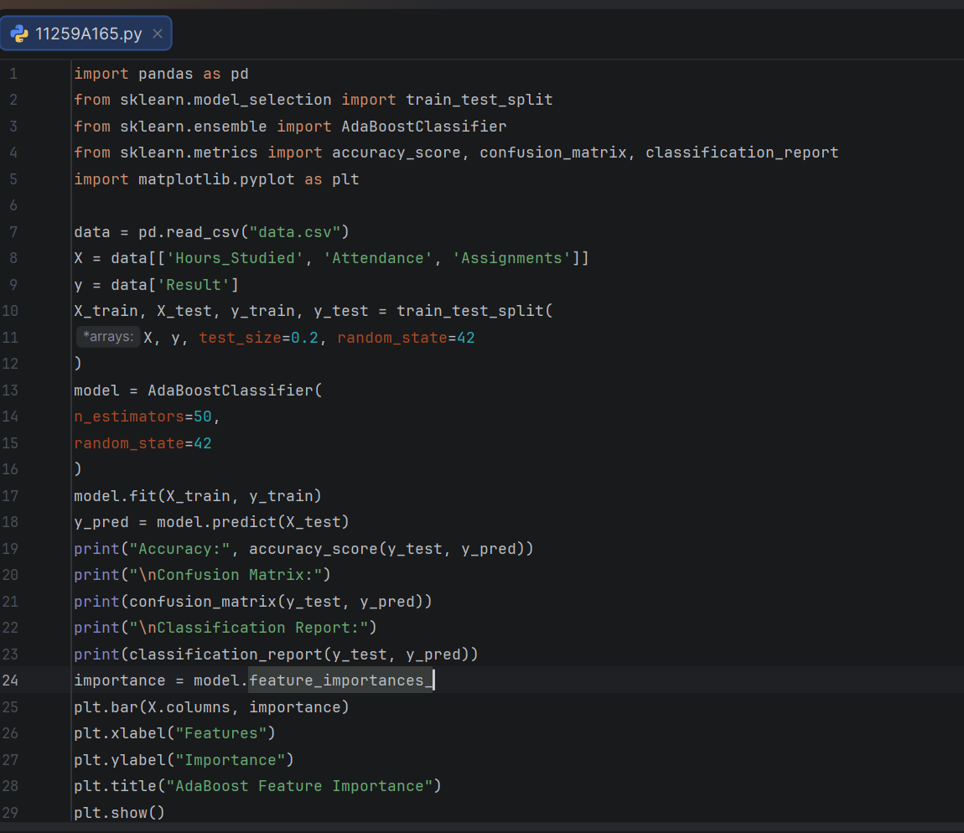
PROGRAM :

OUTPUT :
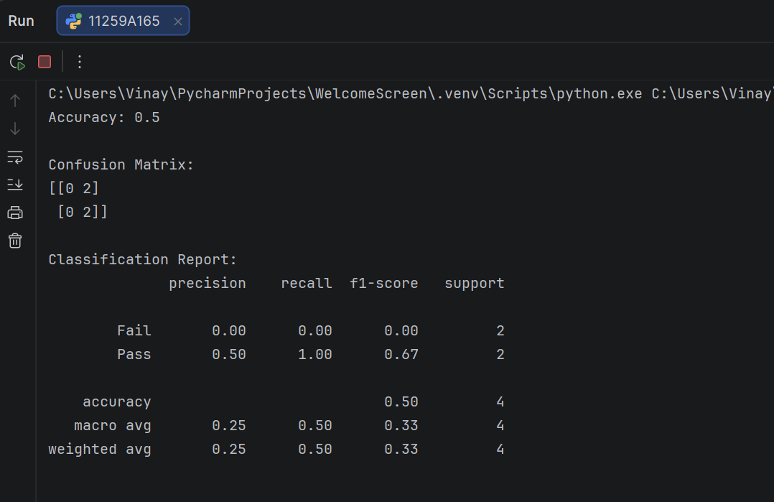
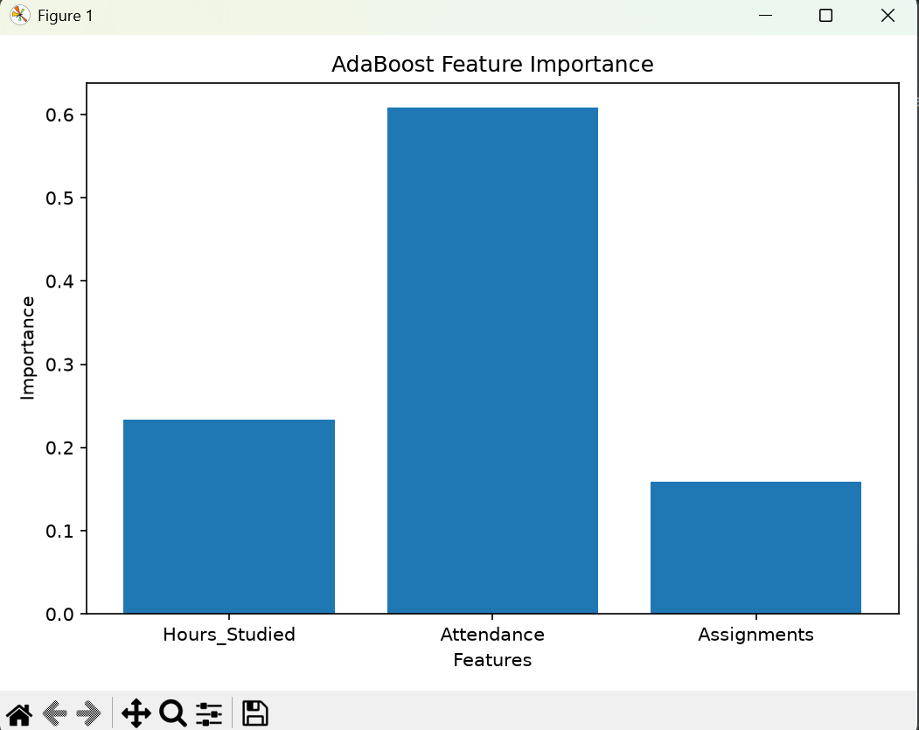

RESULT : Thus, the AdaBoost Classification algorithm was implemented successfully to predict students' results based on their study hours, attendance, and assignments. The model's performance was evaluated using accuracy, confusion matrix, and classification report. A feature importance bar graph was also generated to visualize the contribution of each input feature to the model.

